Annex A
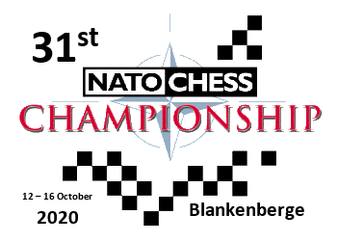
INFORMAL AGREEMENT
(to be returned before May 1st 2020)
NATION
PARTICIPATION (YES or NO)
TOTAL NUMBER OF MEMBERS
(if possible, divided into male and female)
 | Male: | Female:
NUMBER OF COMPETITORS
NUMBER OF GUESTS
NAME AND RANK
PHONE NUMBER
E-MAIL
SIGNATURE AND DATE

