Annex B/1
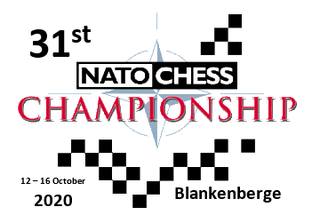
FINAL AGREEMENT
(to be returned not later than August 15th 2020)
NATION
Date of bank transfer
Means of transportation
Date of arrival
Place of arrival
Time of arrival
Pick up service
(at Railway Station Blankenberge)
Date of departure
Time of departure
Special requirements
(food, accommodation, allergies, etc)
NAME AND RANK
PHONE NUMBER
E-MAIL
SIGNATURE AND DATE

Annex B/2
FINAL AGREEMENT
(to be returned not later than August 15th 2020)
NATION
 | NAME | FIRST NAME | DATE OF BIRTH | Playing Chess  (YES or NO) | NATO TEAM  (YES or NO) | FIDE-ID
Team Official
Team Captain
Player 1
Player 2
Player 3
Player 4
Player 5
Player 6
LTM 1
LTM 2
LTM 3
GUESTS |  |  |  | If applicable, spouse of guest of who?
GUEST 1
GUEST 2
GUEST 3

